User add :



Add group:



Add user to group:



Change user ID:



Change group ID:



Set user password:

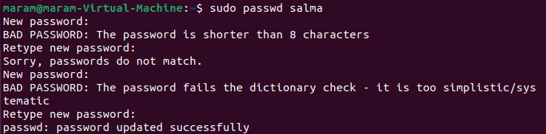

Create Dir:



Change owner :



Change permission : (full permission)



Check:





